DDoS Attack Analysis Report

Overview
This report analyzes the web server log file s_chalauri25_18943_server.log to identify time intervals of a DDoS attack using regression analysis. The approach includes parsing timestamps, aggregating request counts per minute, fitting a linear regression model to establish the baseline traffic trend, calculating residuals, detecting anomalies (residuals > 3× standard deviation), and grouping consecutive anomalies into attack intervals. The provided visualization confirms a dramatic spike in traffic consistent with a DDoS event.

Log File
The event log file is available at: s_chalauri25_18943_server.log

Detected DDoS Time Interval(s)
- 2024-03-22 18:55:00+04:00 to 2024-03-22 18:57:00+04:00
This interval contains the extreme traffic spike (peak ~11,564 requests/minute) detected as statistical anomalies by the regression model.

Methodology
- Parse Log: Extract timestamps using regex and datetime.
- Aggregate: Group by minute to obtain requests-per-minute time series.
- Regression: Linear regression (time in minutes as predictor, requests as response) using statsmodels.OLS.
- Anomaly Detection: Residuals exceeding 3σ threshold.
- Interval Construction: Merge consecutive anomalous minutes.
- Visualization: Plot actual counts, regression line, and anomalies.

Key Code Fragments
Full script: ddos_analysis.py

Parsing & Aggregation
Python
import re
import pandas as pd
from datetime import datetime

with open('s_chalauri25_18943_server.log', 'r') as f:
lines = f.readlines()

timestamps = []
for line in lines:
match = re.search(r'\[(\d{4}-\d{2}-\d{2} \d{2}:\d{2}:\d{2}\+\d{2}:\d{2})\]', line)
if match:
dt = datetime.strptime(match.group(1), '%Y-%m-%d %H:%M:%S%z')
timestamps.append(dt)

df = pd.DataFrame({'timestamp': timestamps})
df['minute'] = df['timestamp'].dt.floor('min')
counts = df.groupby('minute').size().reset_index(name='requests')

Regression & Anomaly Detection
Python
import statsmodels.api as sm
import numpy as np

counts['time_min'] = (counts['minute'] - counts['minute'].min()).dt.total_seconds() / 60
X = sm.add_constant(counts['time_min'])
model = sm.OLS(counts['requests'], X).fit()
counts['predicted'] = model.predict(X)
counts['residual'] = counts['requests'] - counts['predicted']
std_res = counts['residual'].std()
counts['anomaly'] = np.abs(counts['residual']) > 3 * std_res

Interval & Visualization
Python
# Interval logic (as previously shown)
# ...

import matplotlib.pyplot as plt
plt.figure(figsize=(12,6))
plt.plot(counts['minute'], counts['requests'], label='Requests per Minute')
plt.plot(counts['minute'], counts['predicted'], color='red', label='Regression Line')
plt.scatter(counts[counts['anomaly']]['minute'],
counts[counts['anomaly']]['requests'],
color='orange', label='Anomalies')
plt.title('Request Counts with Regression and Anomalies')
plt.xlabel('Time')
plt.ylabel('Number of Requests')
plt.legend()
plt.grid(True)
plt.savefig('ddos_visualization.png')
plt.show()

Results and Visualizations
Key Metrics at Peak:
Minute | Requests | Predicted | Residual | Anomaly
2024-03-22 18:55:00+04:00 | ~9408 | ~2005 | +7403 | True
2024-03-22 18:56:00+04:00 | ~11564 | ~2035 | +9529 | True
Visualization: Request Counts with Regression and Anomalies
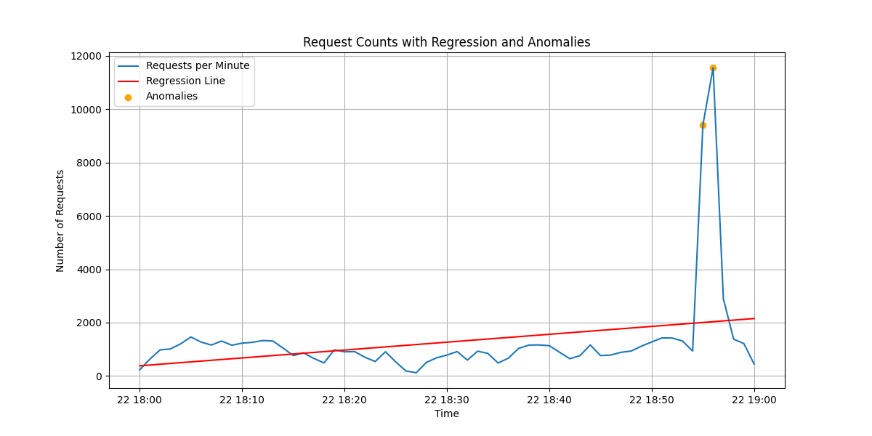
The plot clearly shows normal traffic fluctuating around the upward regression trend until a massive spike at approximately 18:55, marked by orange anomaly points. This deviation is far beyond normal variation and matches the classic signature of a DDoS attack.

